COMPOSITE ELECTRODE MODEL
As part of our last conversation, I was able to manage to understand the Gr-SiO_{X} composite anode material through the MSMR model using the Sam Dao Paper.
The MSMR model then represents the equilibrium potential of that gallery(j) as.
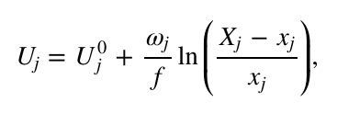
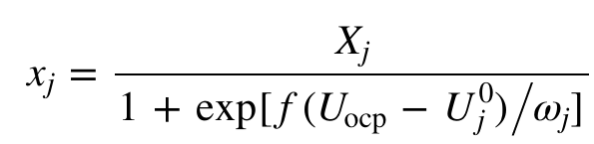
- $X_{j}$= (Total number of host sites in gallery $j$, both filled and unfilled)
÷ (Total number of host sites across all galleries). In other words, $X_{j}$represents the fraction of total host sites that belong to gallery $j$.
- $x_{j}$= (Number of filled host sites in gallery $j$) ÷ (Total number of host sites in gallery $j$, both filled and unfilled). Thus, $x_{j}$represents the fraction of filled sites within gallery $j$.
- So, I took initially one graphite OCV (literature) and tried to fit it using a 7-gallery step for the MSMR model. I was able to fit it close to 7mv error (figure 2).
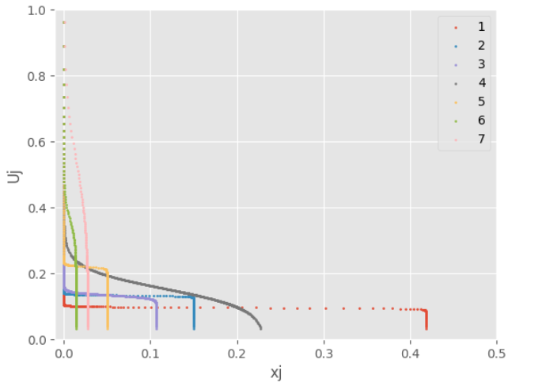
Figure 1 : The potential in which the different reaction species/ gallery (Gr-7) operates and the mole fraction it fills.
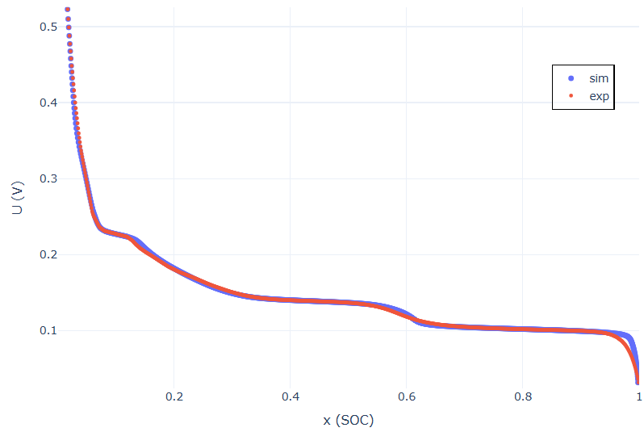
Figure 2 : Experimental Gr OCV (red) and MSMR fitted Gr OCV (blue).
- And then I tried to implement the composite MSMR by considering two species Gr and SiO_{X}, trying to fit the BAK anode composite OCV measured from the coin cell with C/30 quasi static current.
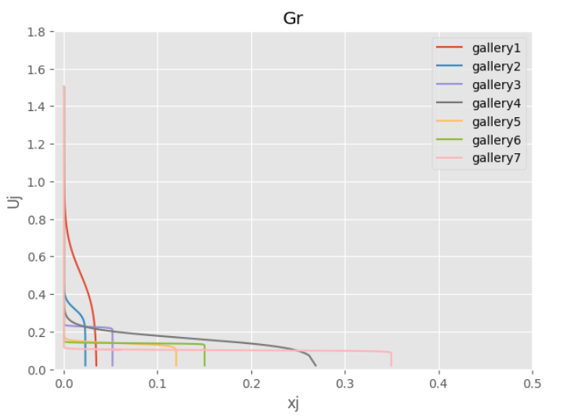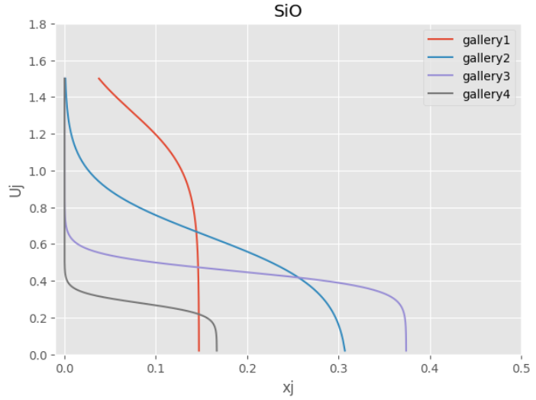
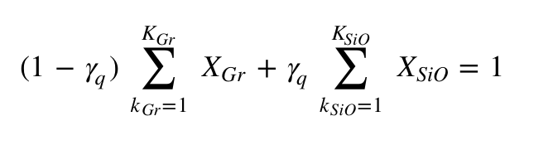
The total fractional capacity of the blend is expressed as the combined sum over both graphite and SiO galleries:

Parameter Definitions:
1. $K_{Gr}$ and $K_{SiO}$ represent the total number of galleries (intercalation reactions) for graphite (7) and SiO (4), respectively.
2. $X_{Gr}$ and $X_{SiO}$ denote the total mole fractions of graphite and SiO in the blend, satisfying the condition $X_{Gr}$ + $X_{SiO}$ = 1.
3. $γ_{q}$ refers to the capacity fraction associated with gallery q of each host material.
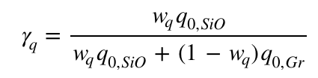
Here, I took the silicon weight percentage as 4.5% (SEM Analysis) and considered specific capacity for silicon as 1650 mAh/g and for graphite as 350 mAh/g.
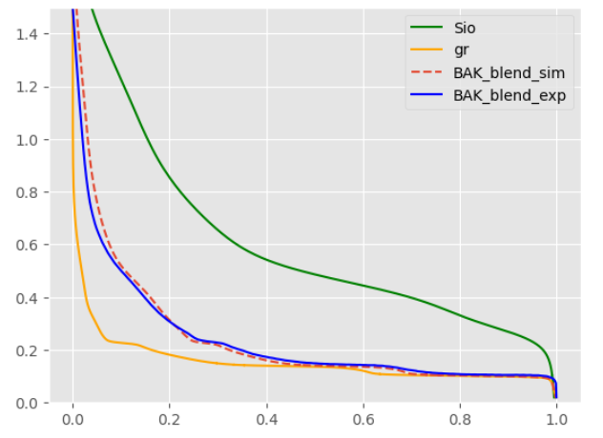
Figure 3
So, by this way I was able to fit the BAK composite anode delithiation OCV using Graphite delithiation OCV and Silicon oxide delithiation OCV separately with 10.07mv RMSE error (Figure 3).
By using these graphite and silicon oxide open circuit potential with the cathode NCA OCV I got from coin cell testing with the same C/30 quasistatic constant current method, I was able to run the low current OCV calibration using Pybamm and achieved a 9.12 mv RMSE error.

